# DAD 220 Project Two Loranger

Summary: This report summarizes the managerial request for a data review of sales and RMA information related to the high RMA occurrences within the Quantrigration product portfolio.

Analysis Note: The data source used in this summary is data available in the ‘QuantigrationUpdates’ database effective 2024-OCT-14 at 19:32 EST. Database data is frozen as a localized copy to ensure consistent data throughout the reporting as follows.

* + There are 37,998 orders in the Orders table
  + There are 37,998 entries in the Collaborators table
  + There are 37,556 entries in the RMA table

**Request: Analyze the sales and RMA data to determine the sales rate vs return rates by product.**

Results: Overall sales by SKU in the data set are shown here on the left and overall RMA by SKU on the right in the following summary. It can be observationally observed in the table below that statistically almost every sale entered has a correlating RMA associated with it. It is probable that some sales have had more that one RMA for a single product, but overall sales vs RMA counts are virtually 1:1 ratio.

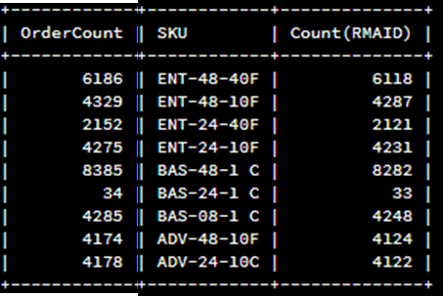

**Request: Analyze the RMA return rates by State.**

Results: When reviewing the RMA data, there is no clear pattern established by State, with 48 states represented in the RMA data with the least being 702 RMA and the maximum being 972 RMA.

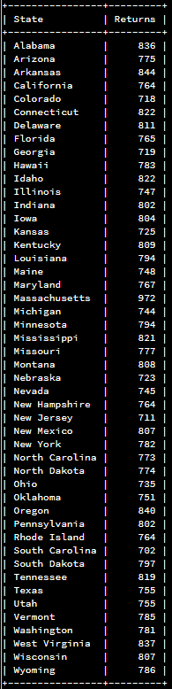

Further Analysis:

When reviewing the reasons for the RMA’s there is an almost even mix (13116 vs 12609) Incorrect vs defective reason code, so ~50% of the RMA requests are attributed to an incorrect sales entry error, configuration error or shipment error.

If the root cause for the Incorrect error code be used, nearly half of all RMAs could potentially be eliminated. Further analysis was performed to attempt to determine a source for the errors.

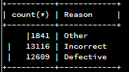

It was investigated to determine if there was perhaps a product that was more dominant in the returns for ‘incorrect’ that could be attributed to a sales system error, stocking error or similar, but there is no meaningful pattern for this query, so the theory of a sales or stocking system defect appears to be false.

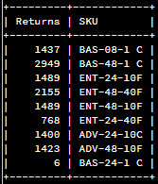

It was investigated if there was an abundance of ‘incorrect’ returns that were demographically correlated, again, no obvious cause was observed. The evidence shows a seemingly even distribution of RMA across all states, which eliminates warehouse locations, sales representatives, and similar regionally specific attributes.

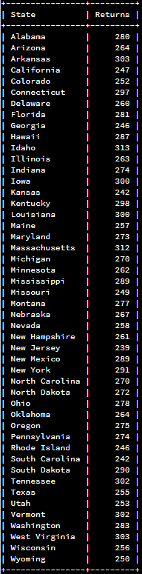

There may exist a data mining solution to the root cause, but it is not apparently obvious with the data analyzed.

For the ‘Defective’ reason code, all instances were resolved by replacement or refund

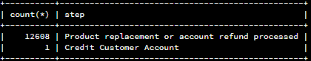

For the ‘Incorrect’ reason code, all instances were resolved by replacement or refund.

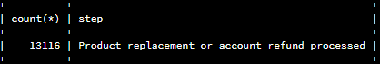

Some opportunities for database enhancement has been noted during the analysis.

* Orders Data table
  + No date information is available to look for timeline correlations
  + No Order Entry method information is available (online, phone, etc)
  + No ordered configuration information is available to compare against shipment configuration information (Neither are available)
  + Order fulfillment details are not available.
  + Shipping logistics details are not available.
* RMA data table
  + No date tracking information is available. Some RMA could be left open for extended periods of time, having a date stamp can be used to priority sort older RMAs to ensure timely resolution.
  + Each step change should be tracked with individual date stamps, and respective technician traceability
  + Reason codes are insufficient to allow detailed analysis, all that is known is that a defect has occurred, there is no ability to determine the highest causes /locations of the defects within each product respectively to help engineering take corrective actions outside of requesting empirical analysis by the RMA Technicians.

With enhanced data tracking details, it might be possible to identify the root cause, but the very high returns for seemingly Human Error needs to be a priority focus to establish root cause and implement corrective actions appropriately immediately to improve efficiency, reduce RMA service costs, and most importantly improve customer satisfactions.

As points of improvement, the RMA tracking tools, Sales Entry tools, shipping tools, etc. need to be investigated for the ability to increase the data that is collected to improve overall tracking and accounting for sales and RMA transactions. This will be a medium-term duration task which can be exercised outside the root cause analysis for ‘Incorrect’ errors.

One additional recommendation would be to interview the RMA personnel to ensure the RMA codes are being used as intended, and they are not just being used as ‘Catch-All’ buckets due to lack of understanding or lack of applicable correct bin options.